 | 14.3.7 Editors - Video Sequence Editor - Sidebar - Sequencer - View tab
Table of content
View Settings Panel 1
Proxy Render Size 1
Use Proxies 1
Prefetch Frames 1
Channel 1
Show Overexposed 2
Frame Overlay Panel 2
Set Overlay Region 2
Frame offset 2
Overlay Type 2
Overlay Lock 2
Scene Strip Display panel 2
Shading 2
Override scene settings 3

View Settings Panel
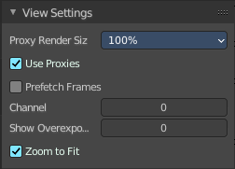
Note that this panel just shows when Preview As Backdrop is activated.

Proxy Render Size
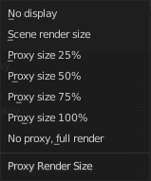
Size to display proxies at in the preview region. Using a smaller preview size will increase speed.
Proxies is a simplified data set to speed up workflow.

Use Proxies
Use proxy images instead of the real material to speed up workflow.

Prefetch Frames
Render frames ahead of current frame in the background for faster playback.

Channel
Which channel number to show in the image preview. The value 0 is the result of all strips combined.

Show Overexposed
Shows overexposed (bright white) areas using a zebra pattern. The threshold can be adjust with the slider.

Frame Overlay Panel
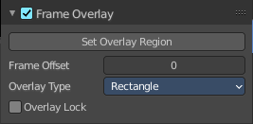
Note that this panel just shows when Preview As Backdrop is activated.

Display an overlay on top of the sequencer with a frame offset of the content.

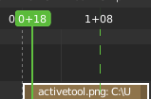
When the feature is active then you will see a green dashed line in the sequencer timeline.

Set Overlay Region
Box select a portion of the viewport to display the overlay content.

Frame offset
What offset frame to use, relative to the current frame position.

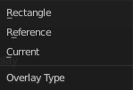
Overlay Type
The overlay draw type.

Overlay Lock
Locks the overlay frame to the current frame. It will not go ahead when you play the video.

Scene Strip Display panel

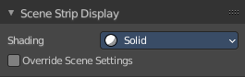
Note that this panel just shows when Preview As Backdrop is activated.
Settings for the strip type Scene Strip.

Shading
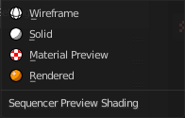
How to display the scene content in the preview window.

Override scene settings
Use the workbench render settings from the sequencer scene instead of the settings instead of each individual scene used in the strip.

